Accurate Room Temperature Controller Project

The main purpose of this Digital Temperature Controller is to control the temperature of any device like AC or any other electronic devices whose temperature keeps fluctuating and thus requires a constant watch on the device. The use of this system eliminates constant watching on the device by self controlling the temperature of the system.
Our proposed project consists of digital temperature sensors for more accurate temperature control in various industries. Our system overcomes the disadvantages of thermostat/analog systems in terms of accuracy. This system can be used in any firm or organization where it is very important to maintain precise temperatures.
LCD display is used to display the temperature and when the temperature exceeds the set limit, the lamp is switched off in order to control the temperature. The heater is demonstrated with the help of a lamp. After the heater is switched off, the AC is switched ON. Here AC is demonstrated with the help of small fan.
After the AC is switched ON, it remains ON until the temperature reaches below the exceed limit. Thus the system keeps on switching ON/OFF the heater or the AC for automatically controlling the temperature of the system. The system uses a digital temperature sensor in order to detect temperature and pass on the data to the microcontroller. The 8051 microcontroller processes data and sends the temperature to be displayed on LCD screen. The display consists of 7 segment display unit to display up to 4 numbers.
It consists of 4 push buttons for setting the high and low temperatures. Pressing set button allows user to increment and decrement high and low temperatures. After that the system detects temperature and switches the load when it goes beyond set limits.

Block Diagram

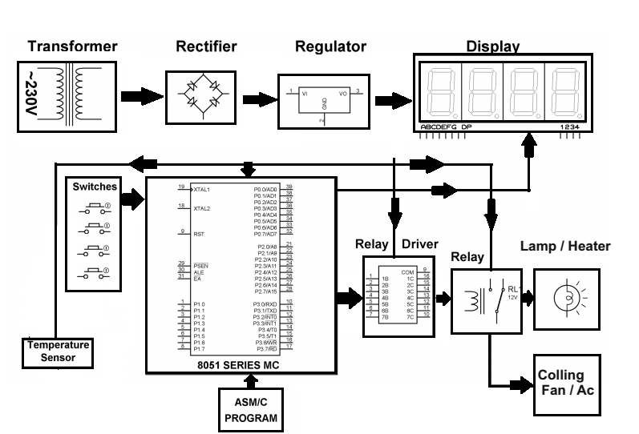

Hardware Specifications
- 8051 series Microcontroller
- 7-Segment Displays
- LED
- Voltage Regulator
- Transformer
- Crystal
- Push Buttons
- Cooling fan
- Temperature Sensor
- Diodes
- Relay
- Lamp

Software Specifications
- Keil µVision IDE
- MC Programming Language: Embedded C

